NST21022 - Practical for Network Switching and Routing
Department of Information and Communication Technology
Faculty of Technology
Lab sheet :13
Reg. Number: SEU/IS/20/ICT/084
Academic Year :2020/2021
Practical No :13

Title: Configure VLANs
Aim:
• Getting familiar with Layer-3 Switching and Inter-VLAN Routing
Task:
• Design a network topology
• Adding VLANs to a Switch
• Configure IP addresses
• Configure Layer 3 switch
• Configure Inter-VLAN Routing

Activities

Exercise 01: Design a Network Topology Use “NST21022 Lab sheet 14.pka” file VLAN and
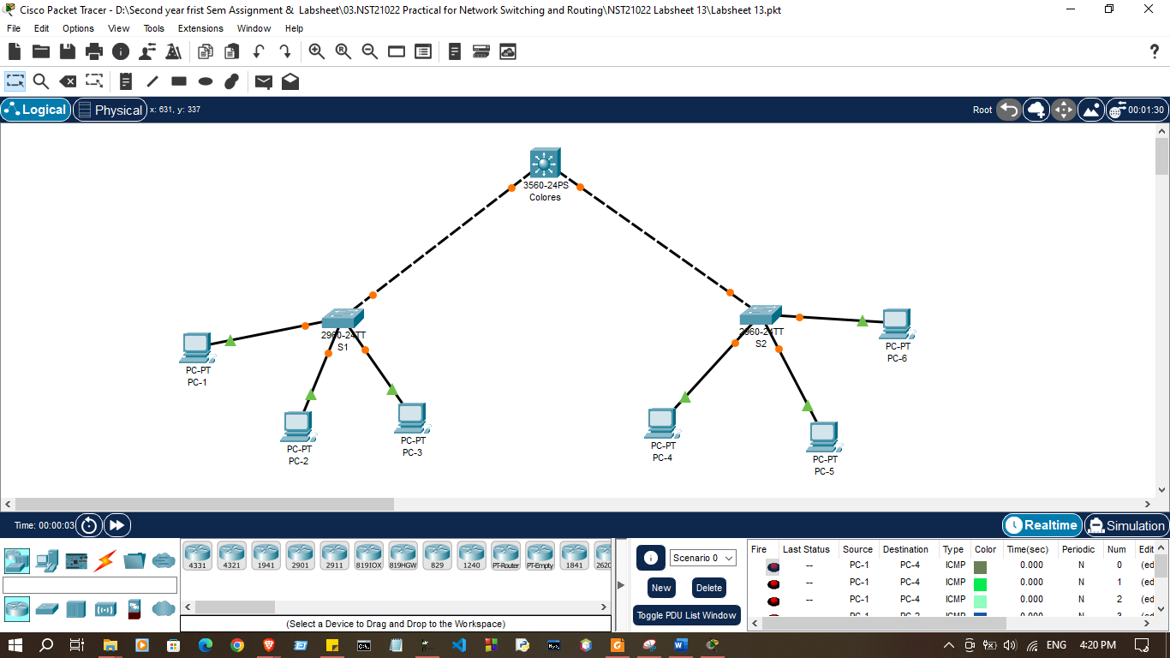

Addressing Table
Device | VLAN | Name | Network | Device
S1 | VLAN 10 | Red | 192.168.1.0/24 | VLAN 10
S1 | VLAN 20 | Green | 192.168.2.0/24 | VLAN 20
S1 | VLAN 30 | Blue | 192.168.3.0/24 | VLAN 30
S2 | VLAN 40 | Yellow | 192.168.4.0/24 | VLAN 40
S2 | VLAN 50 | White | 192.168.5.0/24 | VLAN 50
S2 | VLAN 60 | Black | 192.168.6.0/24 | VLAN 60

Device | Interface | IP Address | VLAN | Device
 | VLAN 10 | 192.168.1.1/24 | VLAN 10
  Colors
 | VLAN 20 | 192.168.2.1/24 | VLAN 20
 | VLAN 30 | 192.168.3.1/24 | VLAN 30
 | VLAN 40 | 192.168.4.1/24 | VLAN 40
 | VLAN 50 | 192.168.5.1/24 | VLAN 50
 | VLAN 60 | 192.168.6.1/24 | VLAN 60
PC-1 | NIC | 192.168.1.10/24 | VLAN 10 | PC-1
PC-2 | NIC | 192.168.2.10/24 | VLAN 20 | PC-2
PC-3 | NIC | 192.168.3.10/24 | VLAN 30 | PC-3
PC-4 | NIC | 192.168.4.10/24 | VLAN 40 | PC-4
PC-5 | NIC | 192.168.5.10/24 | VLAN 50 | PC-5
PC-6 | NIC | 192.168.6.10/24 | VLAN 60 | PC-6

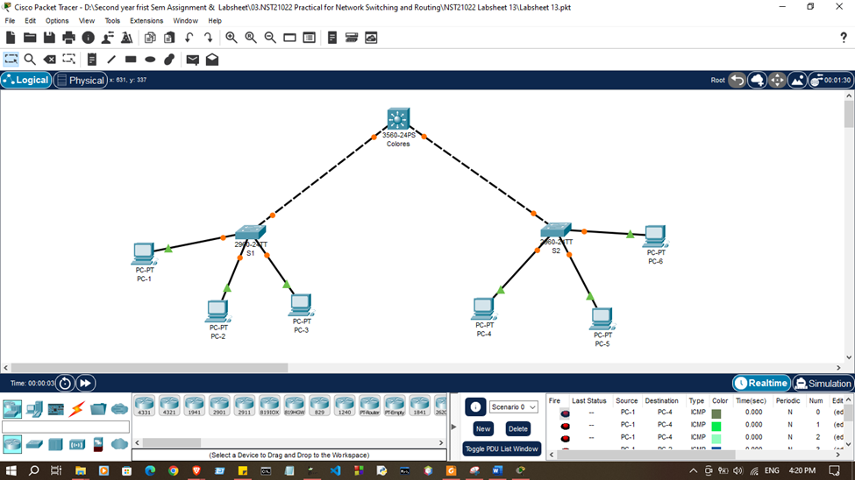
- Create a network topology with layer 3 switch including another 2, layer 2 switch.

- Create additional VLANs on Colors, S1 and S2 according to the table above.

Colors>enable
Colors#configure terminal
Enter configuration commands, one per line. End with CNTL/Z.
Colors(config)#hostname Colors
Colors(config)#
Colors(config)#vlan 10
Colors(config-vlan)#name Red
Colors(config-vlan)#vlan 20
Colors(config-vlan)#name Green
Colors(config-vlan)#vlan 30
Colors(config-vlan)#name Blue
Colors(config-vlan)#vlan 40
Colors(config-vlan)#name Yellow
Colors(config-vlan)#vlan 50
Colors(config-vlan)#name White
Colors(config-vlan)#vlan 60
Colors(config-vlan)#

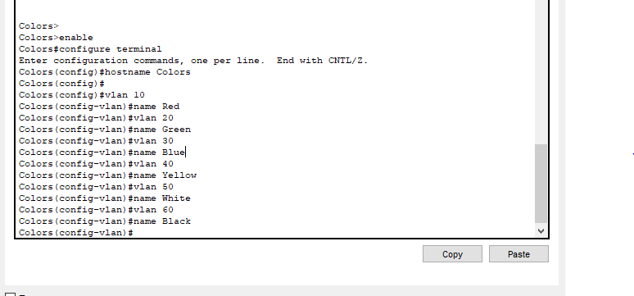
S1>enable
S1#configure terminal
Enter configuration commands, one per line. End with CNTL/Z.
S1(config)#hostname S1
S1(config)#
S1(config)#vlan 10
S1(config-vlan)#name Red
S1(config-vlan)#vlan 20
S1(config-vlan)#name Green
S1(config-vlan)#vlan 30
S1(config-vlan)#name Blue
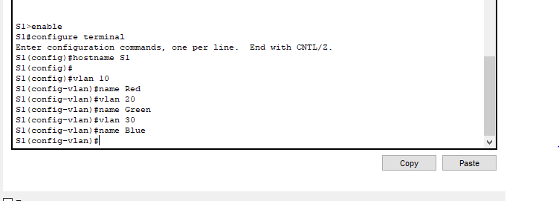
S1(config-vlan)#

2>enable
S2#configure terminal
Enter configuration commands, one per line. End with CNTL/Z.
S2(config)#hostname S2
S2(config)#
S2(config)#vlan 40
S2(config-vlan)#name Yellow
S2(config-vlan)#vlan 50
S2(config-vlan)#name White
S2(config-vlan)#vlan 60
S2(config-vlan)#name Black
S2(config-vlan)#
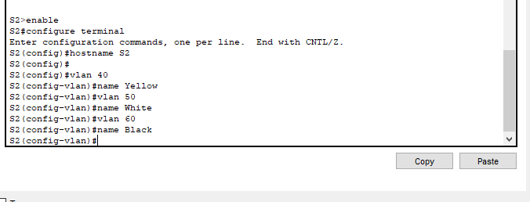

- Assign Ports to VLANs

S1(config-vlan)#
S1(config-vlan)#exit
S1(config)#interface range f0/1-10
S1(config-if-range)#switchport mode access
S1(config-if-range)#switchport access vlan 10
S1(config-if-range)#
S1(config-if-range)#interface range f0/11-19
S1(config-if-range)#switchport mode access
S1(config-if-range)#switchport access vlan 20
S1(config-if-range)#
S1(config-if-range)#interface range f0/20-24
S1(config-if-range)#switchport mode access
S1(config-if-range)#switchport access vlan 30
S1(config-if-range)#
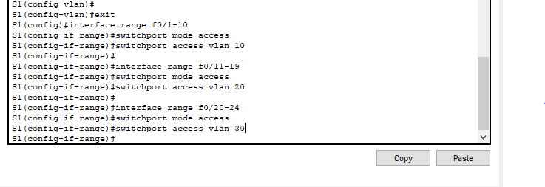

S2(config)#interface range f0/1-10
S2(config-if-range)#switchport mode access
S2(config-if-range)#switchport access vlan 40
S2(config-if-range)#
S2(config-if-range)#interface range f0/11-20
S2(config-if-range)#switchport mode access
S2(config-if-range)#switchport access vlan 50
S2(config-if-range)#
S2(config-if-range)#interface range f0/21-24
S2(config-if-range)#switchport mode access
S2(config-if-range)#switchport access vlan 60
S2(config-if-range)#
S2(config-if-range)#interface g0/1
S2(config-if)#switchport mode access
S2(config-if)#switchport mode trunk
S2(config-if)#
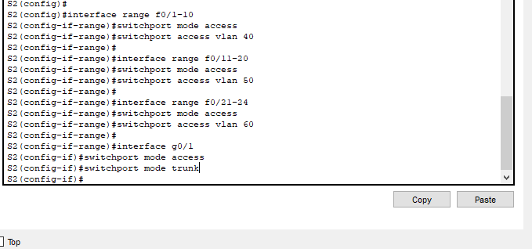

- Configure Switch Virtual Interface (SVI) on Colors

Colors(config)# interface vlan 10
Colors(config-if)# ip address 192.168.1.1 255.255.255.0

Colors(config)#interface vlan 10
Colors(config-if)#ip address 192.168.1.1 255.255.255.0
Colors(config-if)#no shutdown
Colors(config-if)#
Colors(config-if)#interface vlan 20
Colors(config-if)#ip address 192.168.2.1 255.255.255.0
Colors(config-if)#no shutdown
Colors(config-if)#
Colors(config-if)#interface vlan 30
Colors(config-if)#ip address 192.168.3.1 255.255.255.0
Colors(config-if)#no shutdown
Colors(config-if)#
Colors(config-if)#interface vlan 40
Colors(config-if)#ip address 192.168.4.1 255.255.255.0
Colors(config-if)#no shutdown
Colors(config-if)#
Colors(config-if)#interface vlan 50
Colors(config-if)#ip address 192.168.5.1 255.255.255.0
Colors(config-if)#no shutdown
Colors(config-if)#
Colors(config-if)#interface vlan 60
Colors(config-if)#ip address 192.168.6.1 255.255.255.0
Colors(config-if)#no shutdown
Colors(config-if)#

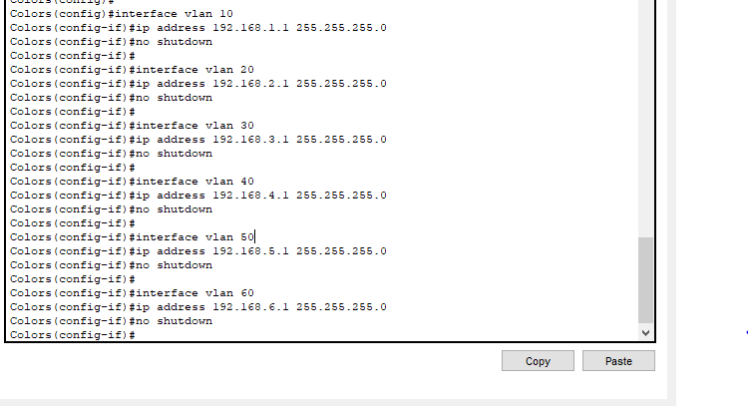

- Configure trunking on Colors

- Configure interface g0/1 and g0/2

Colors(config)#
Colors(config)#interface range g0/1-2
Colors(config-if-range)#
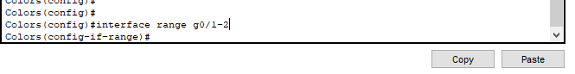

- Make the interface a static trunk mode

Colors(config-if-range)# switchport mode trunk

Colors(config-if-range)#switchport mode trunk
Colors(config-if-range)#

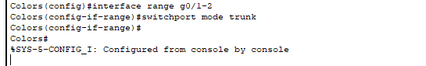

- Encaplsulate the link with the dot1q protocol
Colors(config-if-range)# switchport trunk encapsulation dot1q

Colors(config)#interface range g0/1-2
Colors(config-if-range)#switchport mode trunk
Colors(config-if-range)#switchport trunk encapsulation dot1q
Colors(config-if-range)#
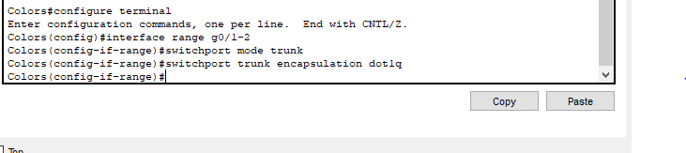

- Configure trunking in S1 and S2

S1(config)#
S1(config)#interface g0/1
S1(config-if)#switchport mode access
S1(config-if)#switchport mode trunk

S1(config-if)#

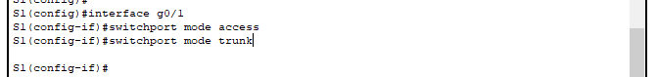

S2(config)#interface g0/1
S2(config-if)#switchport mode access
S2(config-if)#switchport mode trunk
S2(config-if)#
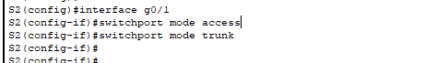

- Enable routing in global configuration mode.
Colors(config)#ip routing

Colors(config)#ip routing
Colors(config)#

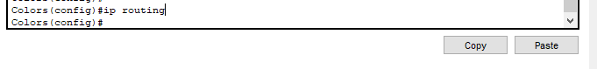

- Check routing table

Colors#show ip route
Codes: C - connected, S - static, I - IGRP, R - RIP, M - mobile, B - BGP
D - EIGRP, EX - EIGRP external, O - OSPF, IA - OSPF inter area
N1 - OSPF NSSA external type 1, N2 - OSPF NSSA external type 2
E1 - OSPF external type 1, E2 - OSPF external type 2, E - EGP
i - IS-IS, L1 - IS-IS level-1, L2 - IS-IS level-2, ia - IS-IS inter area
* - candidate default, U - per-user static route, o - ODR
P - periodic downloaded static route

Gateway of last resort is not set

C 192.168.1.0/24 is directly connected, Vlan10
C 192.168.2.0/24 is directly connected, Vlan20
C 192.168.3.0/24 is directly connected, Vlan30
C 192.168.4.0/24 is directly connected, Vlan40
C 192.168.5.0/24 is directly connected, Vlan50
C 192.168.6.0/24 is directly connected, Vlan60

Colors#
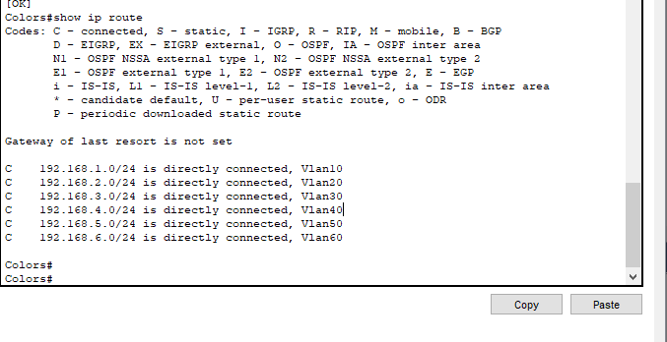
- Verify connectivity

Discussion
- In this lab session, we focused on understanding Layer-3 switching and configuring inter-VLAN routing. We began by designing a network topology that included multiple VLANs to segment the network and improve security. After setting up the network, we added VLANs to the switch and assigned specific VLAN IDs to relevant switch ports. Next, we configured IP addresses for the devices within each VLAN to enable proper communication. By enabling Layer 3 switching, we were able to route traffic between VLANs directly on the switch without the need for a router. This was done by configuring the switch as a Layer 3 device and setting up inter-VLAN routing, ensuring seamless communication across different VLANs within the network.

